Information on tourist spots around Ojiya
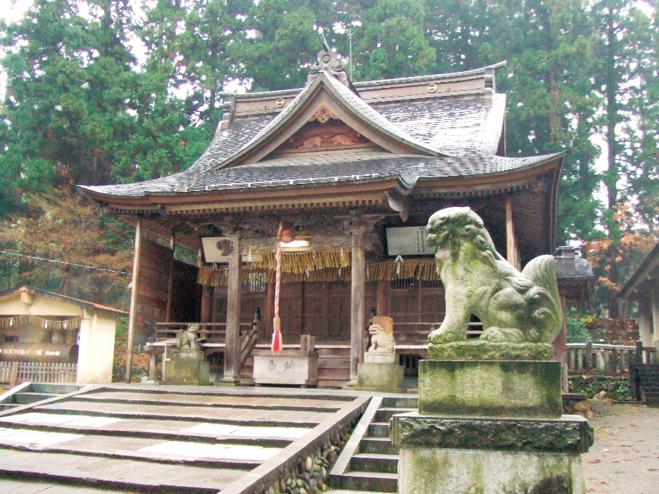
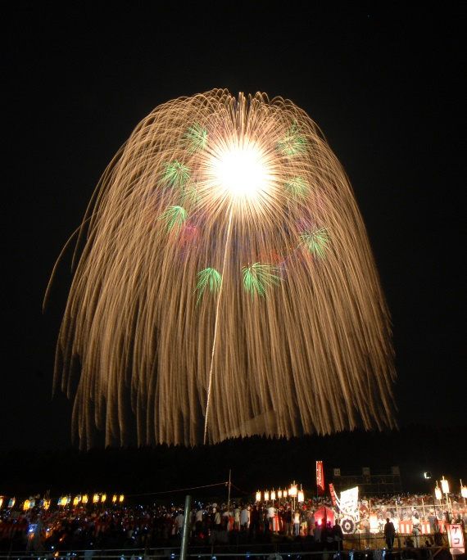
Katakai Festival

Katakai Festival is one of the most famous festivals in Japan and has gradually been gathering attentions overseas. This festival is known for the second biggest firework which explodes into a breathtaking large flower about 800m in diameter. It has been held since Edo period and is a historical event that dedicates fireworks to Asahara shrine. The fireworks display is not only for entertainment but also each firework is set off with hearts and hopes of pyrotechnists and locals.
In katakai, it is a tradition for graduates to create graduates’ association when people graduate Katakai junior high school. Those associations sponsor fireworks for Katakai festival in their milestone years such as coming of age and 60th birthyear.
The large firework used to be the world biggest firework until the record was broken in Dubai on New Year’s Day of 2019. Although it isn’t No.1 in its size, it is still the most beautiful and amazing firework in the world.

